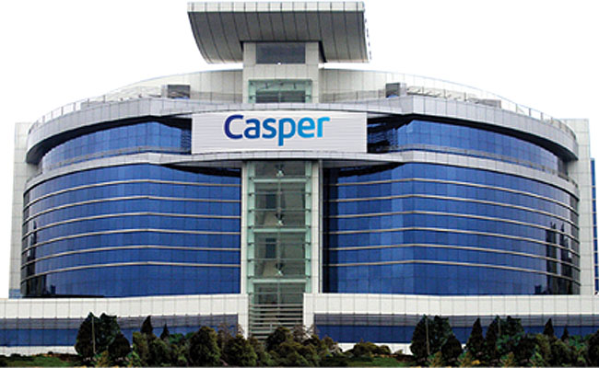**CASPER PLAZA USE CASE**

Within the scope of the project, it is aimed to increase the efficiency of air-conditioning and lighting systems.

**In the current state,**

1. Casper Plaza uses a building automation system for air conditioning systems. With this system

a. Heating or cooling system is operated seasonally. The building manager decides transition date of heating or cooling system. The transition takes between approx. 2-3 days.

b. Fresh air is provided by adjusting the outdoor temperature by ventilation system. System parameters are adjusted manually.

2. Lighting in Casper Plaza is managed manually.

**With the project,**

*Building Automation System*

1. **The new system** will decide season transition dates according to the outside temperature and the meteorological data.

2. **The new system** will decide , temperature of interior space based on how many people there are inside the building, using AI

3. Ventilition system will work automatically depend on office air conditions that are oxygen, carbon dioxide, temperature, humidity levels and number of personel.

*Lighting system*

1. A system will run based on season and light levels of offices and sun light conditions of outside of building

2. **The system with AI** decides which lamp(s) should be switched on and to personel position in offices. The amount of light emitted by the lamps can be adjusted automatically.